LAB Logbook
Lab 5
Week 5
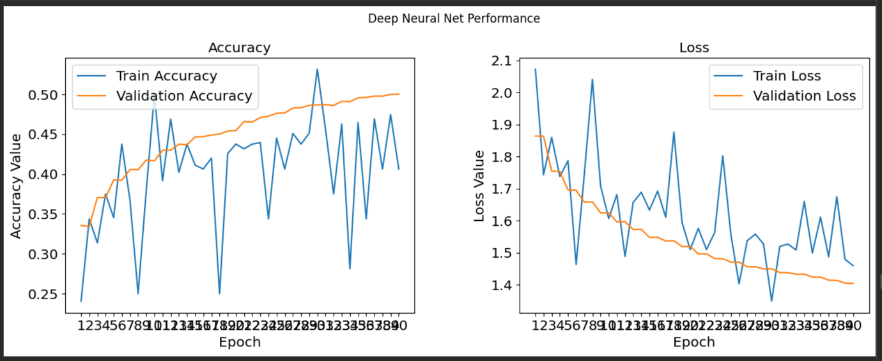
Fig 1: Loss vs Accuracy for VGG16
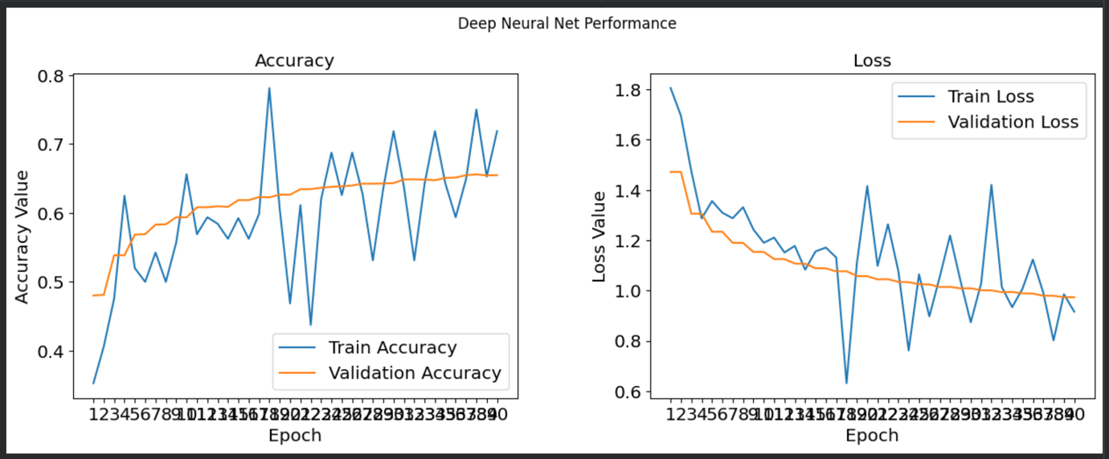
Fig 2: Loss vs Accuracy for VGG19
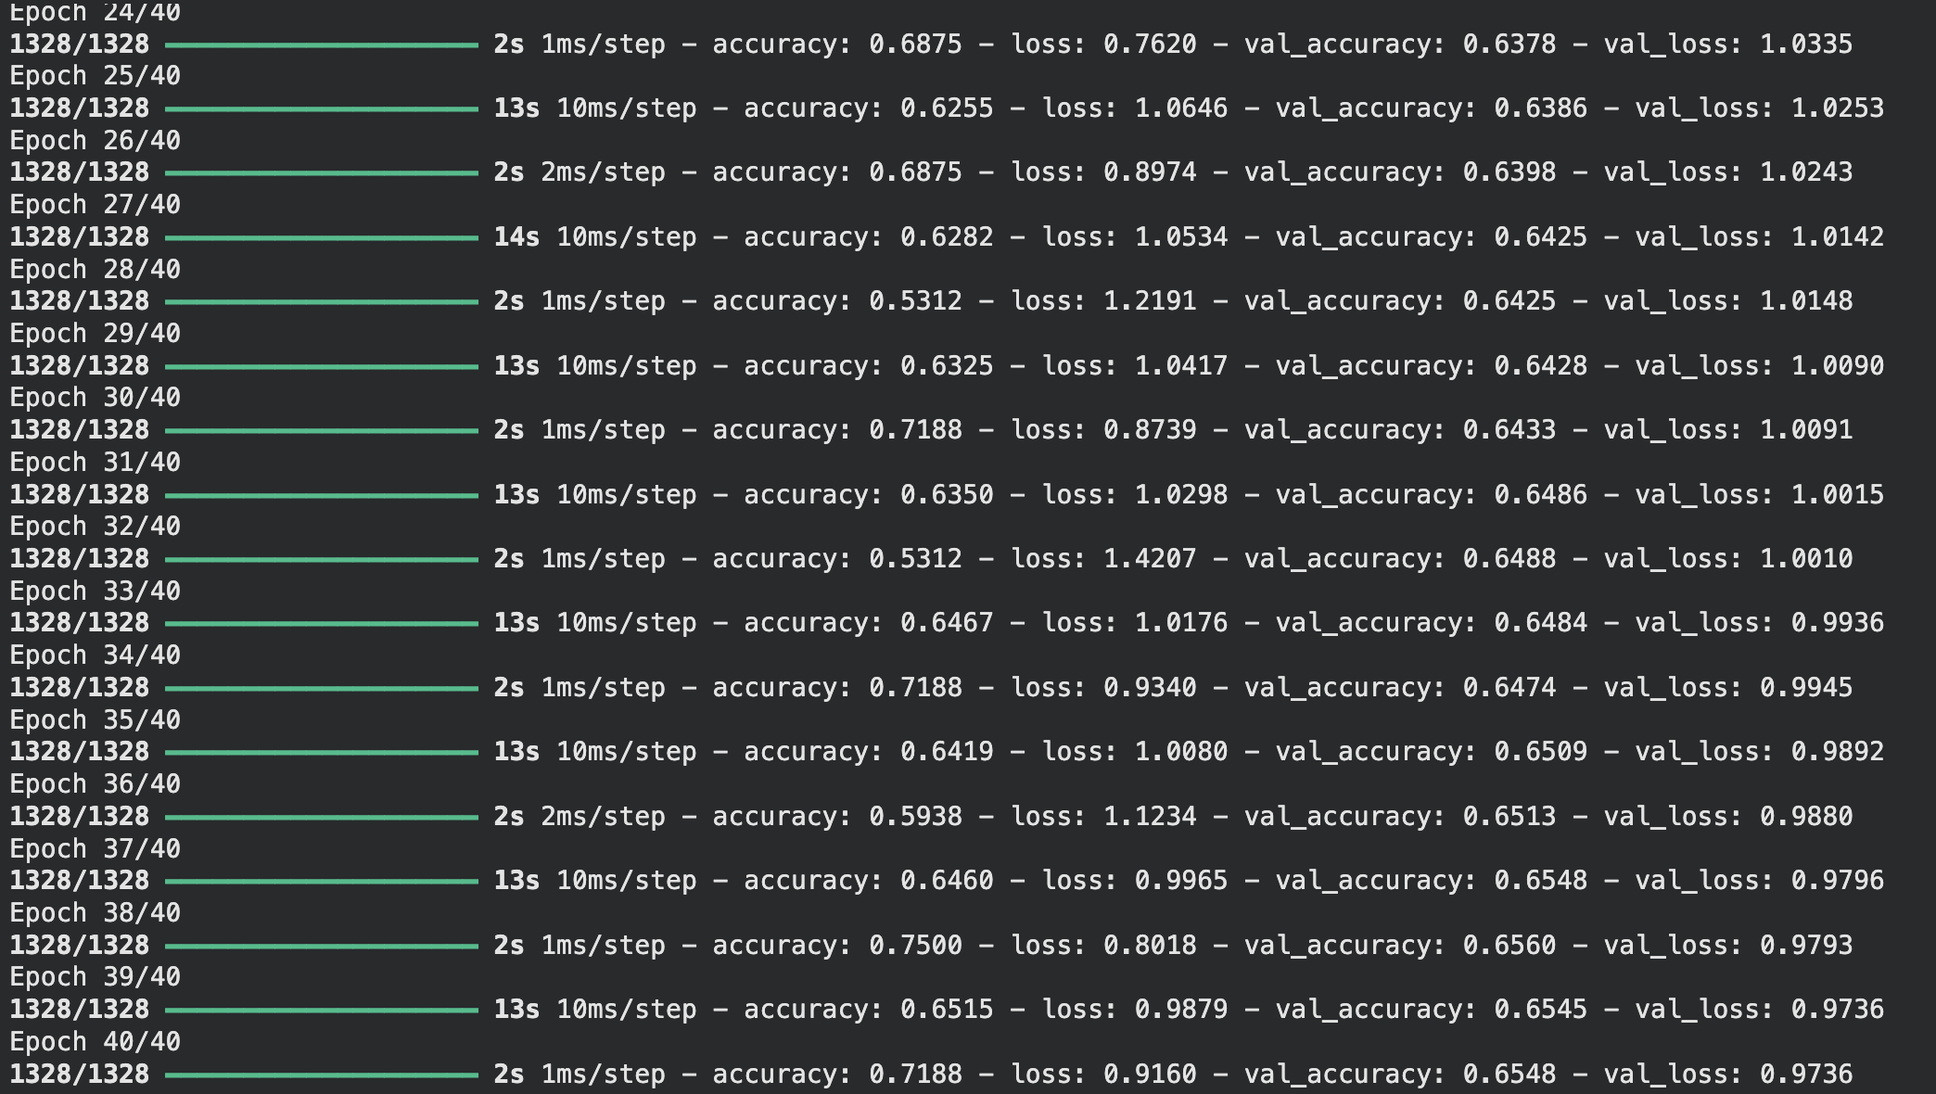
Fig 3: EPOCHS for VGG16
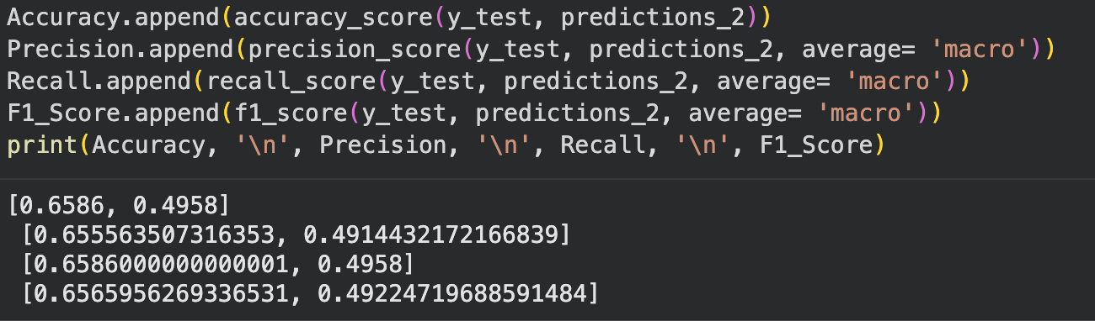
Fig 4: Performance Metrics for VGG16

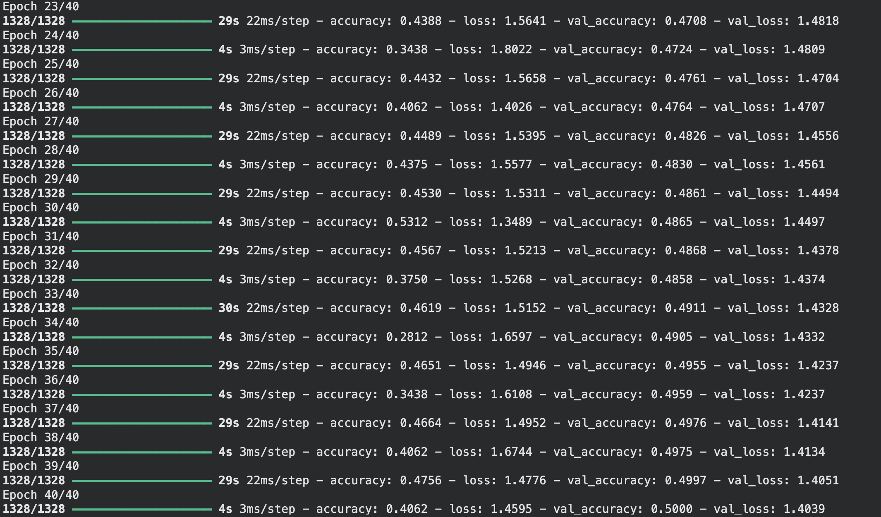
Fig 5: EPOCHS For VGG19
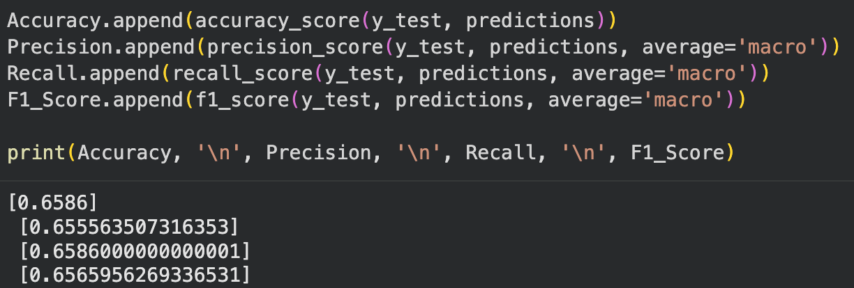
Fig 6: Performance Metrics for VGG19

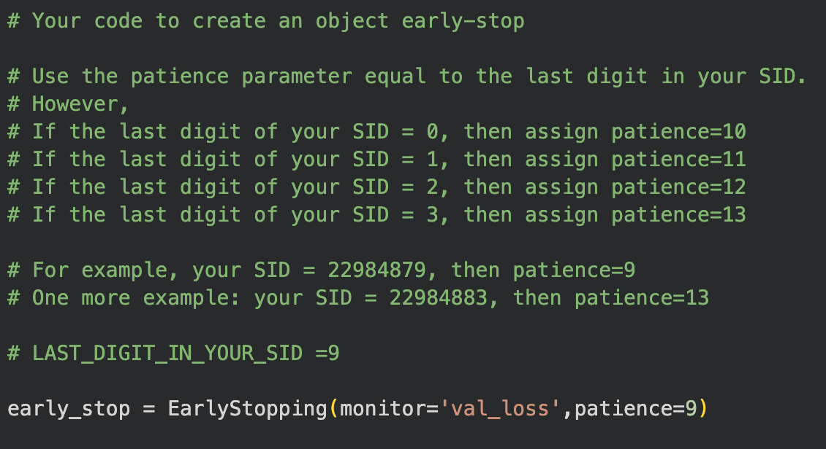
Fig 7: EarlyStopping Code
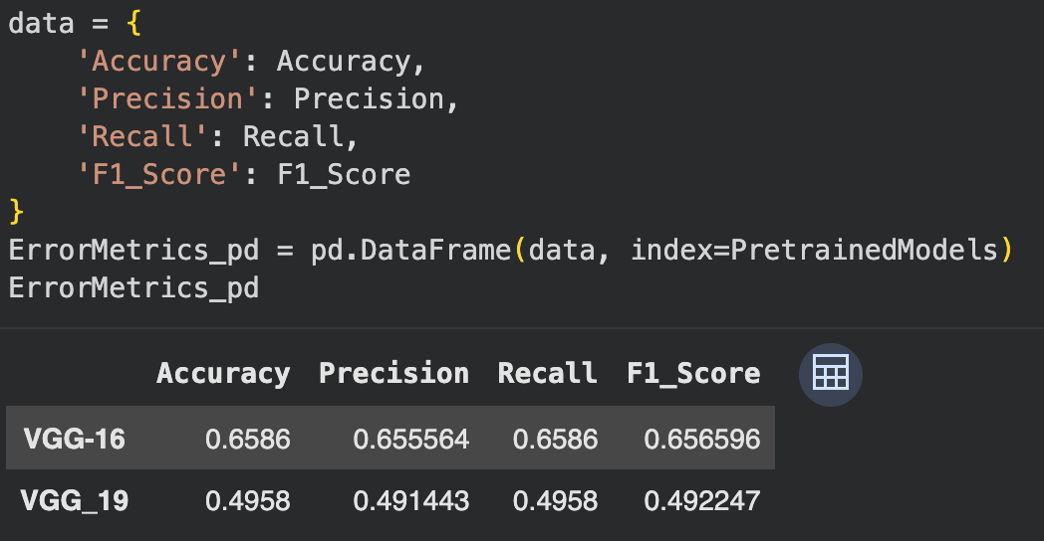
Fig 8: Performance Table

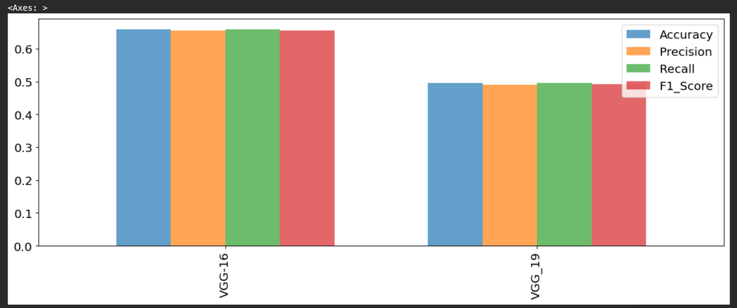
Fig 9: Performance histogram of VGG16 AND VGG19

